

“A STUDY OF CREATION OF USED CAR PRICE EVALUATION MACHINE LEARNING MODEL”

Submitted by:

**RAHUL AHUJA**

**INTRODUCTION**

* Business Problem

With the covid 19 impact in the market, we have seen lot of changes in the car market. Now some cars are in demand hence making them costly and some are not in demand hence cheaper. One of our clients works with small traders, who sell used cars. With the change in market due to covid 19 impact, our client is facing problems with their previous car price valuation machine learning models. So, they are looking for new machine learning models from new data.

* Conceptual Background of the Domain Problem

With the covid 19 impact in the market, we have seen lot of changes in the car market. Now some cars are in demand hence making them costly and some are not in demand hence cheaper. One of our clients works with small traders, who sell used cars. With the change in market due to covid 19 impact, our client is facing problems with their previous car price valuation machine learning models. So, they are looking for new machine learning models from new data. So we need to collect the data from the different websites which deals in the used cars segment to create a model which can actually predict the price of the used cars based on its fetaures. The data/features includes like Brand, model, variant, manufacturing year, driven kilometers, fuel, number of owners, location and at last target variable Price of the car.

* Motivation for the Problem Undertaken

The Motive behind doing this study and analysis is:

* To understand the customer requirement and taste that helps the traders to deal this accordingly
* It helps in doing the price evaluation of used cars.

**Analytical Problem Framing**

* Mathematical/ Analytical Modeling of the Problem

The paper made exploratory research on the need, Problems, influencing factors in business of the used cars. This study based on the comprehensive review of the literature, theories and models have been carried out to propose the models for understanding the buying and selling patterns of the used cars so that the prices of the cars have been evaluated and the maximum profits can be earned out of it. Five major factors that contributed to the study are: Brand and Model ability, Manufacturing Years, Driven Kilometers, Type of fuel, number of owners used the car.

* Data Sources and their formats

The Data has been collected from Different websites which includes [www.cardekho.com](http://www.cardekho.com),[www.cars24.com](http://www.cars24.com), [www.carwale.com](http://www.carwale.com), [www.mahindrafirstchoice.com](http://www.mahindrafirstchoice.com). The selenium method has been used to extract the data from these websites with the use of the Python. We have extracted the total data 6824 used cars from these websites. The extracted data includes different details like Brand Name, Model Name, Variant Name, Manufacturing Year, Kilometers Driven by car, Fuel Type, Number of owners used the car, Location, Price of the car and the Name of the websites from where the details have been extracted. The total Data Includes 6824 rows and the 10 columns.





* Data Pre-processing Done

Below are the steps taking for pre-processing and cleaning the data for the  
 analysis.

* Extract the data from the different websites which includes [www.cardekho.com](http://www.cardekho.com), [www.cars24.com](http://www.cars24.com), [www.carwale.com](http://www.carwale.com), [www.mahindrafirstchoice.com](http://www.mahindrafirstchoice.com)
* The Selenium method is used to scrap the data from these websites.
* Total 6824 used cars data have been extracted from these websites which includes details like Brand Name, Model Name, Variant Name, Manufacturing Year, Kilometers Driven by car, Fuel Type, Number of owners used the car, Location, Price of the car and the Name of the websites from where the details have been extracted.
* There are no null values.
* Most of the data are object type except Manufacturing year, Driven Kilometers and the Price of the car.
* The outliers and the skewness is available in the data which has been removed before processing the Model.
* Rectified the string data for visualization.
* Used Label Encoder for converting the object data into Integer for further analysis.
* Used power transform method for standardization of the data
* Data Inputs- Logic- Output Relationships

The data has been categorized into two and that has been given x and y

y data contains the columns (Price of the used car).

x data contains the complete data except the Price column which will help to understand the relationship of all the other columns with each other and help to predict the value of y (Price of the used car).

**Model/s Development and Evaluation**

* Identification of possible problem-solving approaches (methods)

Visualizations



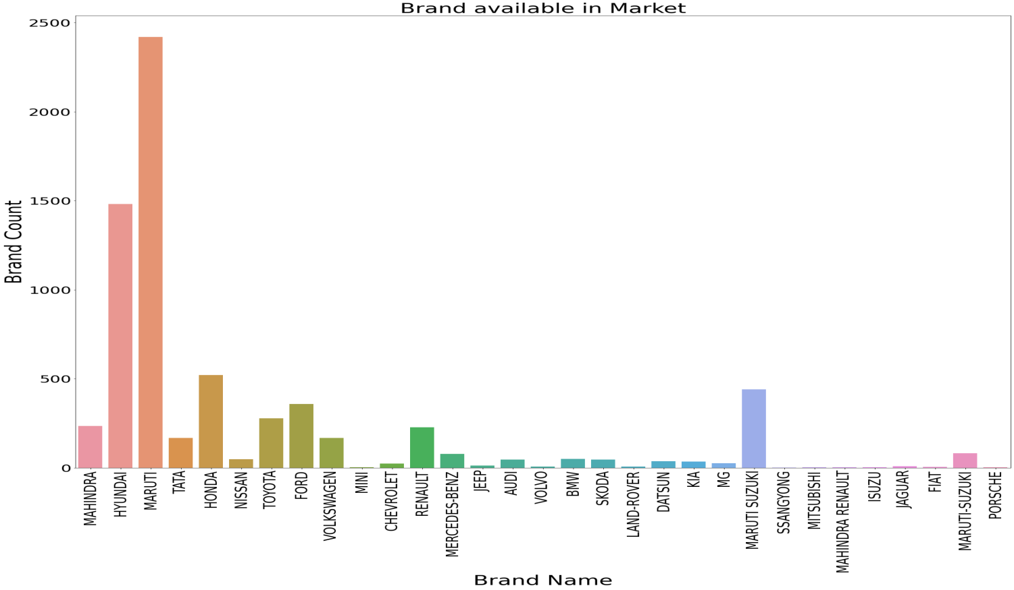

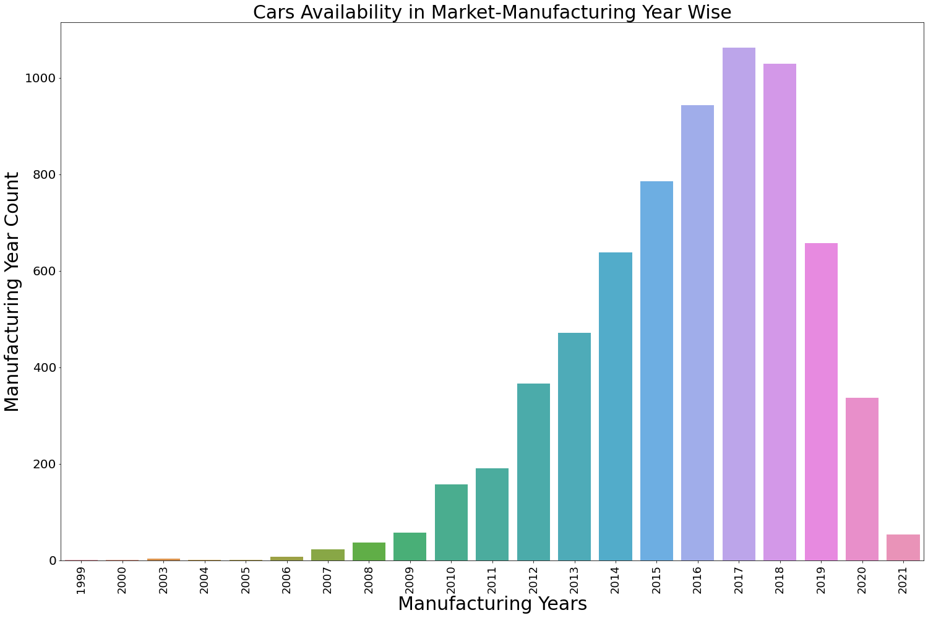

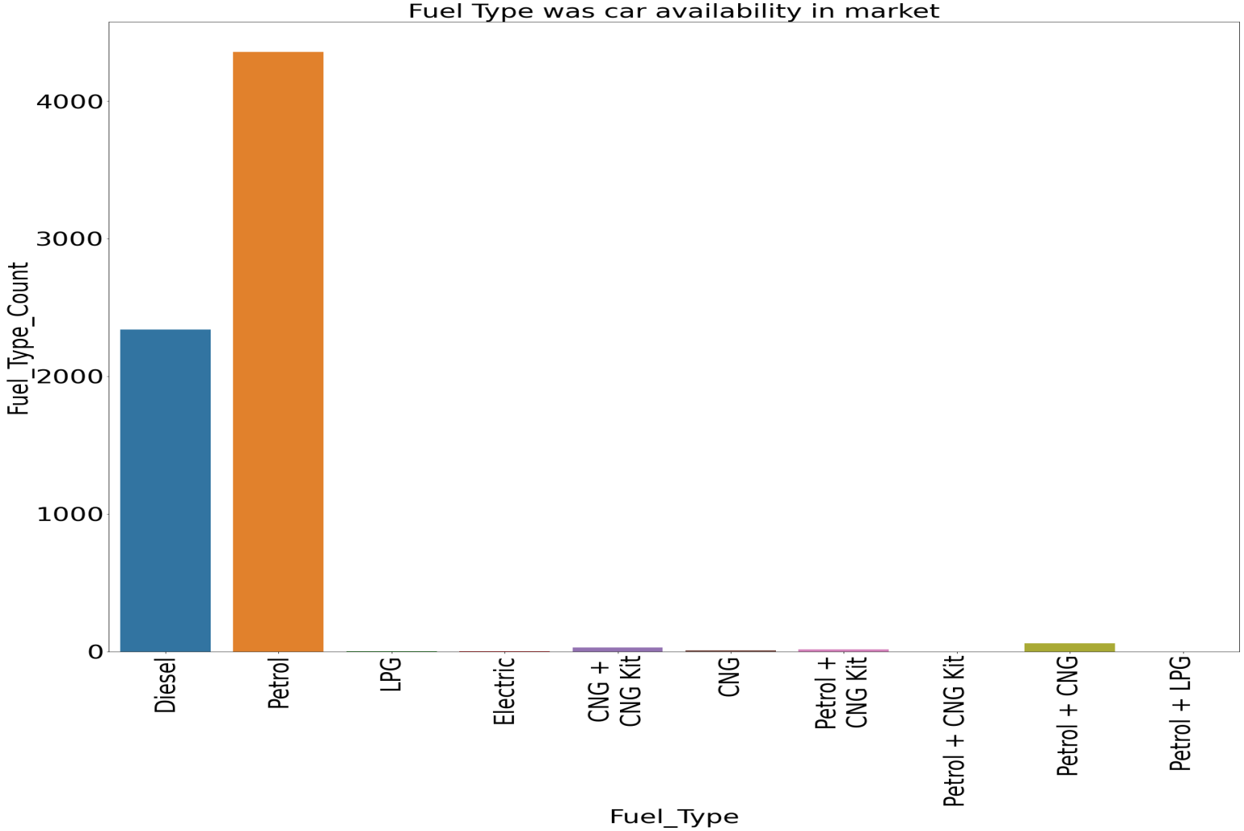

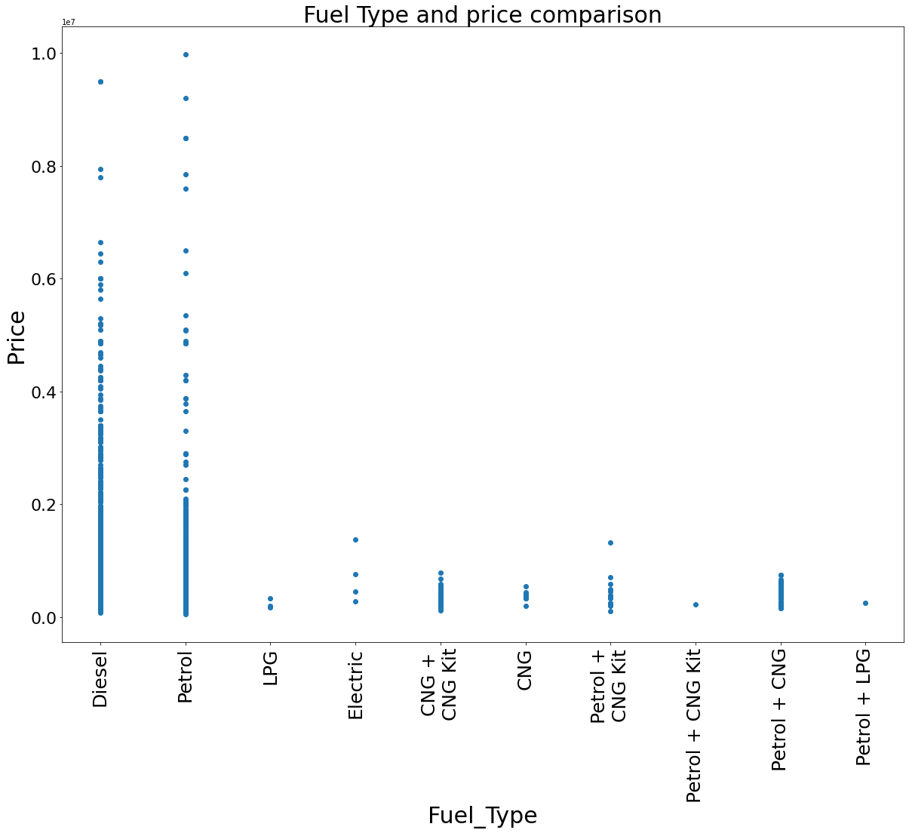

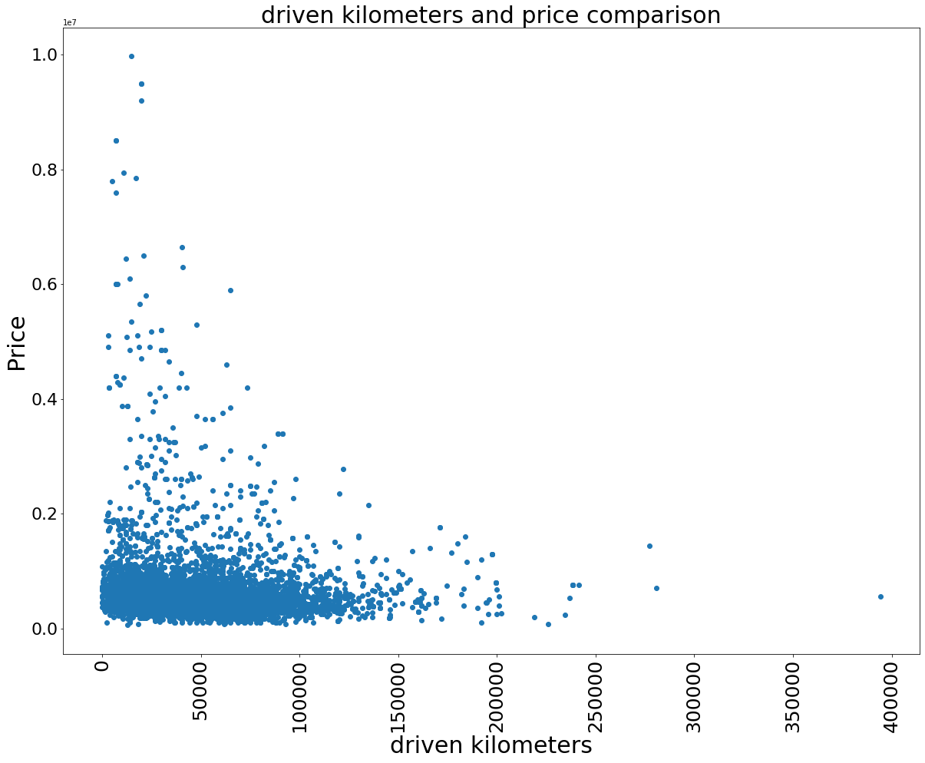

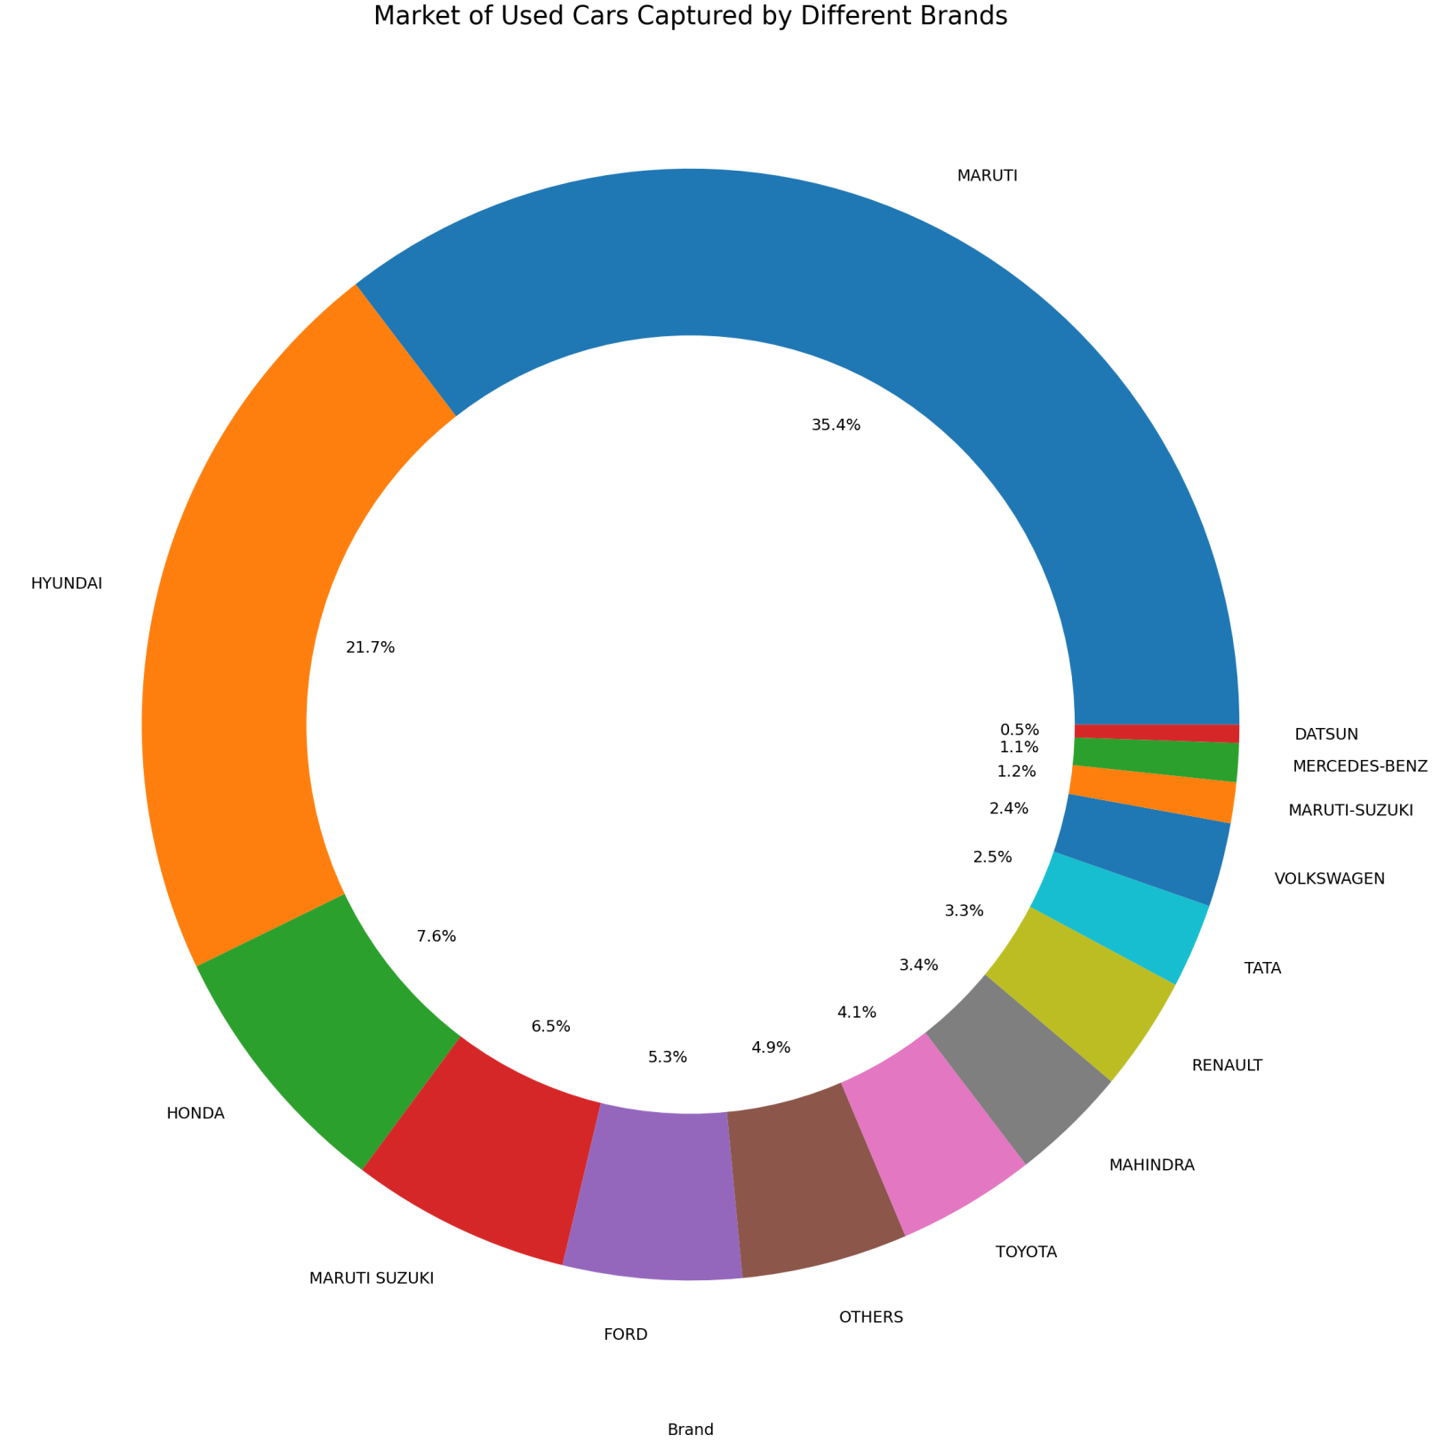

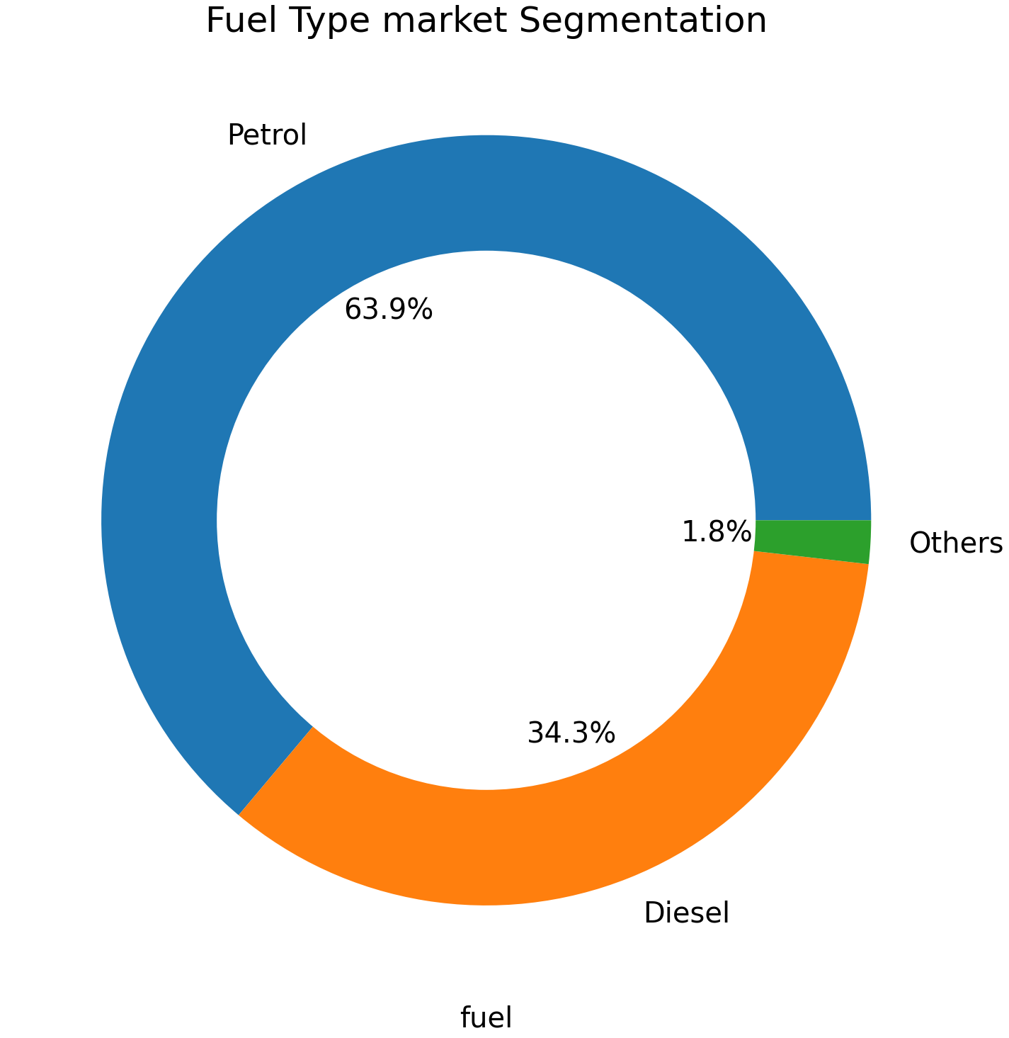

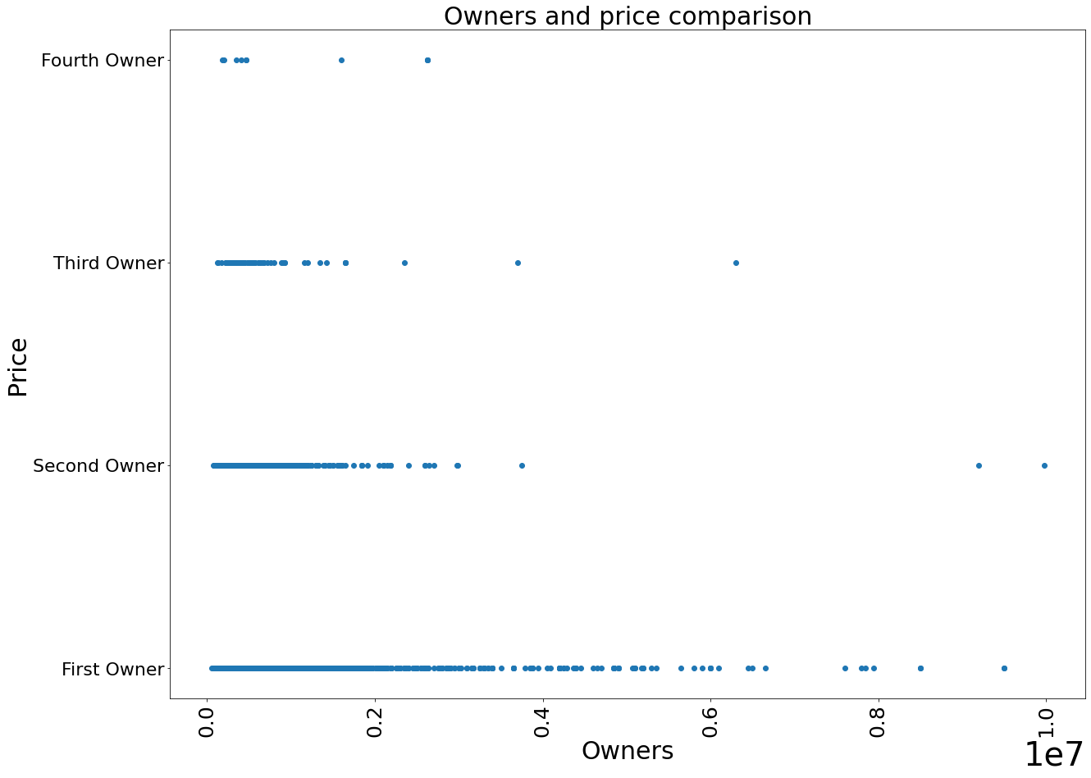

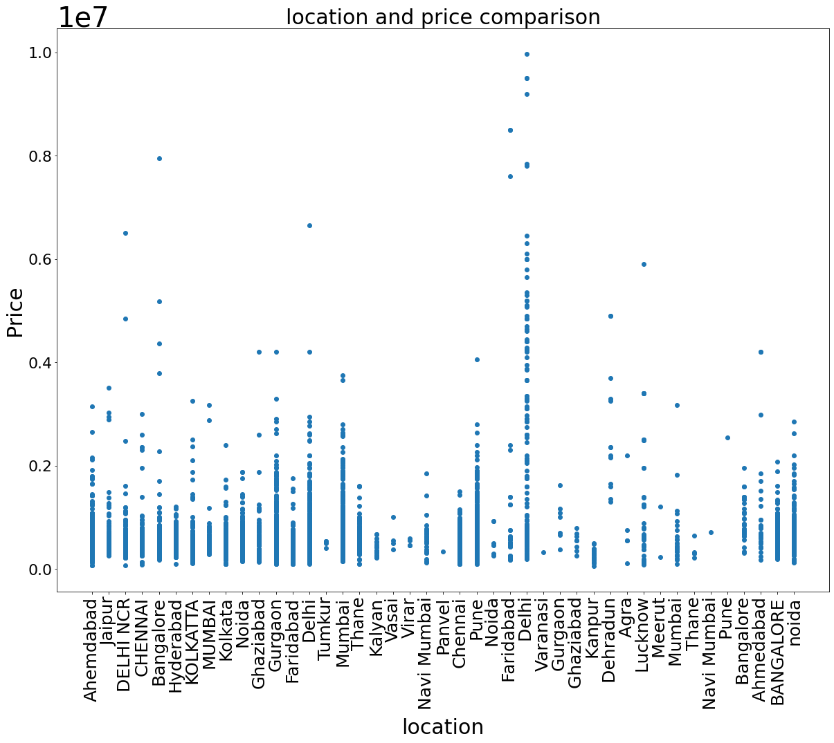

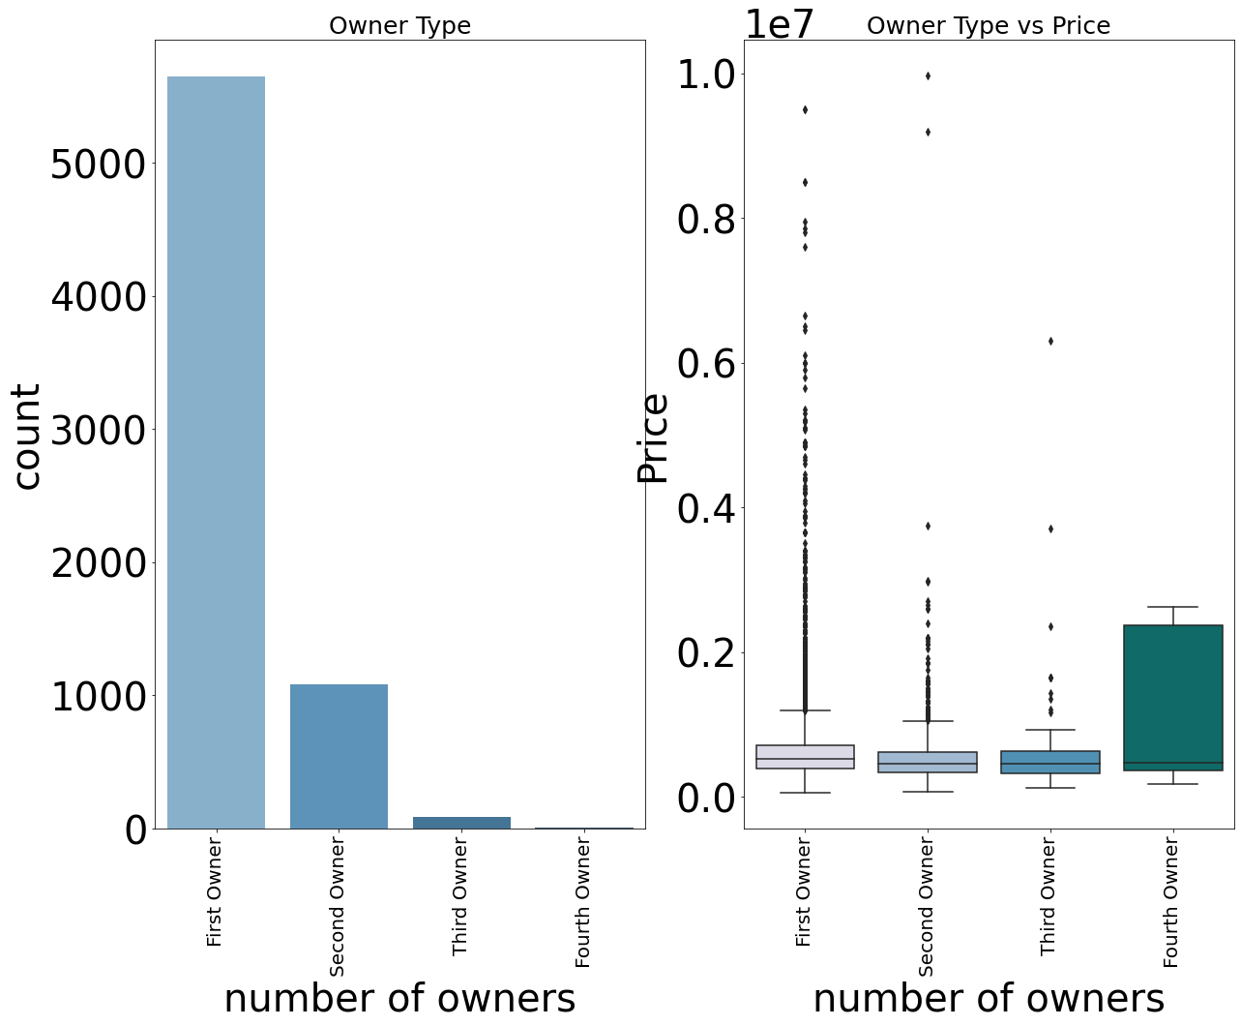

**CORRELATION CHART**

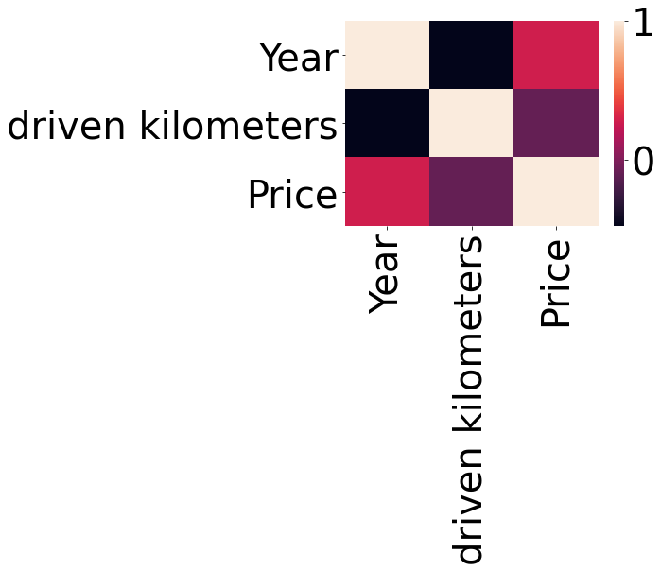

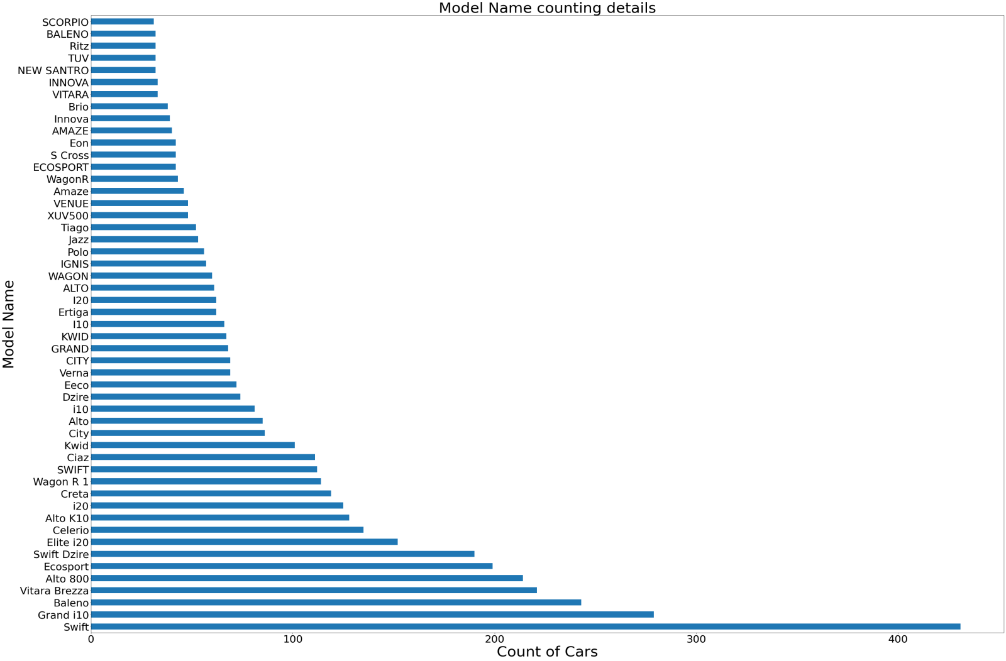

**Skewness in Data**

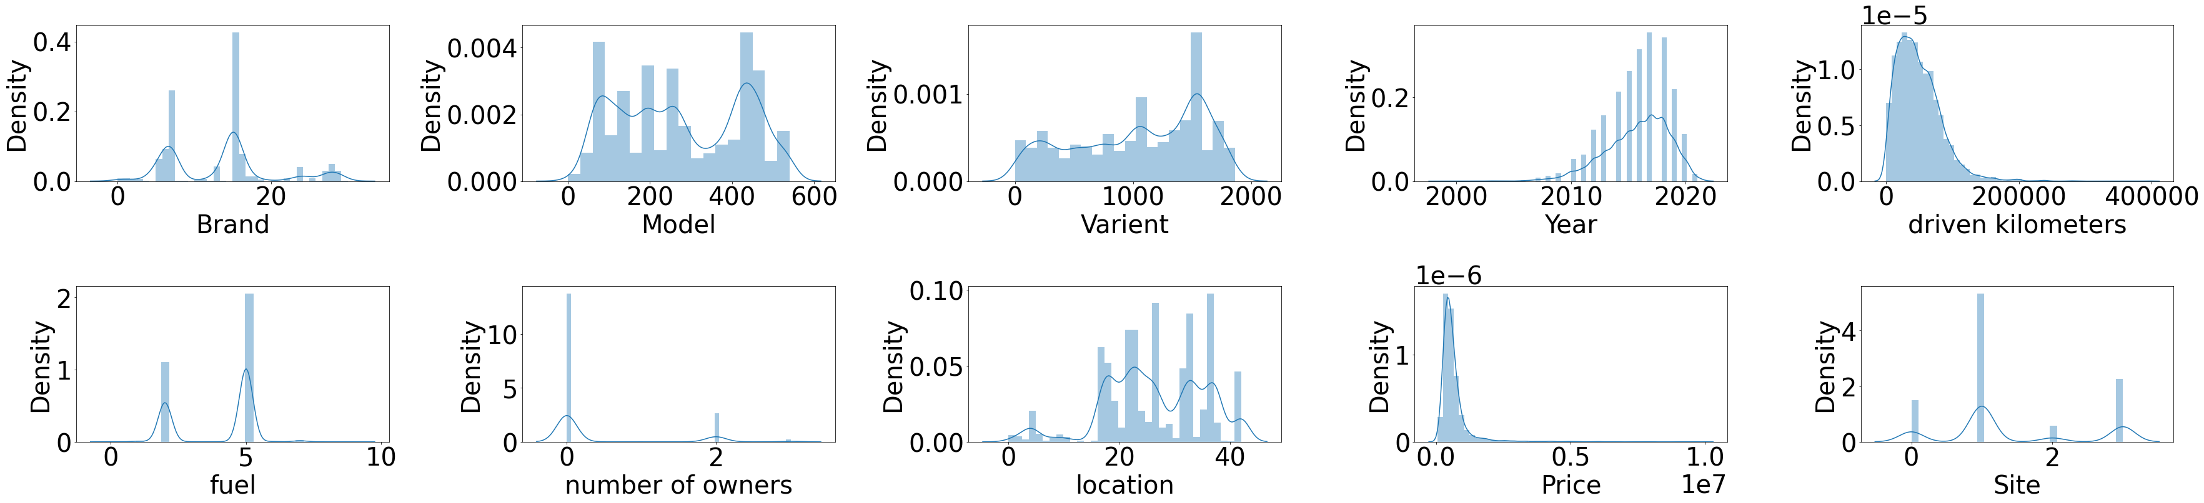

**Outliers in Data**

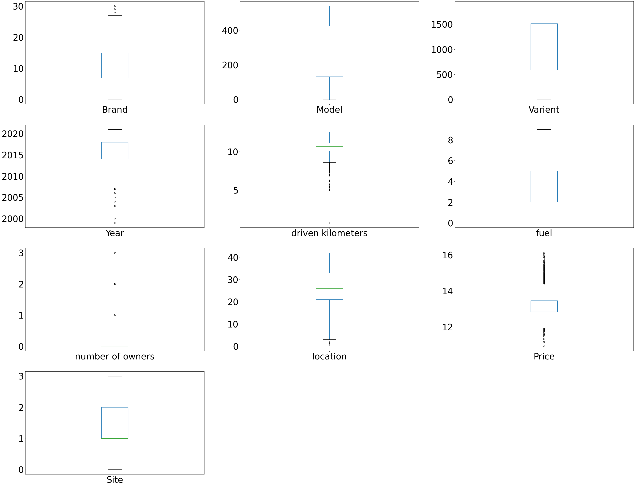

* Key Findings of the study

1. MARUTI and the HYUNDAI are the best available Brands in used cars market. Most of the customers prefer to sell/Buy MARUTI & HYUNDAI.
2. mostly used cars belongs to the manufacturing year of 2017 & 2018 in comparison to other year
3. The availability of the vehicle type Diesel and Petrol are high in the market.
4. The selling prices of Diesel and the Petrol vehicles are high in comparison to other vehicle types.
5. Price and the Driven Kilometer have negative correlation with each other. The more the kilometers increases the more the prices of a used car decreases.
6. Most of the market share has been taken over by Hyundai (21.7%) and Maruti (35.4%).
7. The Mainly market of used cars are captured by Patrol Car which is 69%, followed by Diesel Car which is 34%.
8. The prices and availability of the used cars are high in Delhi NCR in comparison to any other city.
9. The No of Owners are the Price have the negative correlation. As the no of the owners increases the price of the cars decreases.
10. The most numbers of used cars available in the market are belongs to the first owner Type.
11. The average buying price of the Premium segment cars are high in comparison to other cars.
12. The average Buying price of the Diesel cars is high in comparison to other cars.
13. The average buying price of the cars belongs to the Manufacturing year 2021 year in comparison to other cars belongs to the other Manufacturing years.
14. The driven kilometers data and the manufacturing year databoth has negative correlation wIth Price which means the price with decrease with the increase of driven kilometer and the manufacturing year.
15. The Car type Swift belongs to Maruti is the most available Brand followed by grand i10 from Hyundai.
16. Most availability of cars belongs to the driven kilometers of 50000-70000 Kms.

* Conclusions of the Study

Below is the conclusion.

After refining the data we have tested different models like Linear Regression,   
 SVR, Decision Tree Regressor, K Neighbors Regressor, Random Forest Regressor,   
 Ada Boost Regressor and the Gradient Boosting Regressor. After checking all this   
 we have found that the Random Forest Regressor has provided the best result.   
 The score of the same is mention below.



Below is the actual data v/s prediction data

